**BANGLADESH UNIVERSITY OF BUSINESS AND TECHNOLOGY (BUBT)**

*A Database projects*

*On*

**EVENT MANAGEMENT SYSTEM**



**Course Code:** CSE 208

**COURSE TITLE**: Database System Lab

**SUBMITTED BY**

| Name | ID | Intake |
| --- | --- | --- |
| Md. Rakib hosen | **21221203059** | **40** |
| Segufta Nasrin Tamanna | **21221203062** | **40** |
| Sabid Rahman | **21221203063** | **40** |
| Farhana Khan | **21221203066** | **40** |
| Nasirul Islam | **21221203067** | **40** |

**SUBMITTED TO**

**Md. Masudul Islam**

*Assistant Professor, Dept. of CSE*

BUBT

**Submission Date**: 21th, July, 2023

**TABLE OF CONTENTS**

Chapter: 1 | **INTRODUCTION** 3

1.1. Motivation/Problem Specification

1.2. Objectives

Chapter: 2 | **DESIGN** 4

2.1 Model & Diagram

2.1.1 Entity Relationship Diagram

2.1.2 Database Schema Diagram

Chapter: 3 | **IMPLEMENTATION** 6

3.1 Technology & Tools

3.2 Database Tables

3.3 Data View

Chapter: 4 | **QUERY** **RESULTS** 7

4.1 Queries

4.1.1 Simple Queries

4.1.2 Joining Queries

4.1.3 Aggregation

Chapter: 5 | **CONCLUSION** 8

**Chapter 1 | INTRODUCTION**

1.1 Motivation/Problem Specification:

The event management industry has witnessed significant growth in recent years, with an increasing number of events being organized on a regular basis. Managing events efficiently and effectively requires proper planning, coordination, and organization of various resources and tasks. However, manual methods of managing events can be time-consuming, error-prone, and lack scalability. Therefore, there is a need for an Event Management System that can streamline the event planning and execution process, enhance productivity, and provide a centralized platform for event-related activities.

1.2 Objectives:

The main objective of this project is to design and develop an Event Management System that offers a comprehensive solution for event planning, coordination, and management. The system aims to automate various tasks involved in event management, such as event registration, attendee management, venue booking, scheduling, budgeting, and communication. The key objectives of the Event Management System include:

1. Provide a user-friendly interface for event organizers to manage all aspects of event planning and execution.

2. Streamline the event registration process for attendees, enabling online registration and payment options.

3. Facilitate efficient management of event details, including scheduling, venue selection, and resource allocation.

4. Enable seamless communication between event organizers, attendees, and other stakeholders.

5. Improve the overall efficiency and effectiveness of event management processes.

By addressing these objectives, the Event Management System aims to revolutionize the way events are planned, organized, and executed, providing a reliable and scalable solution for event management professionals.

**Chapter 2 | DESIGN**

2.1 Model & Diagram

2.1.1 Entity Relationship Diagram (ERD):

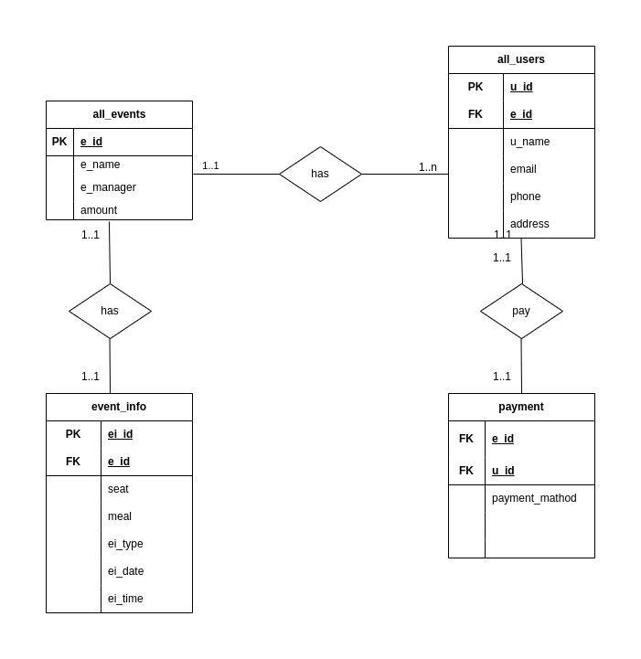

2.1.2 Database Schema Diagram:

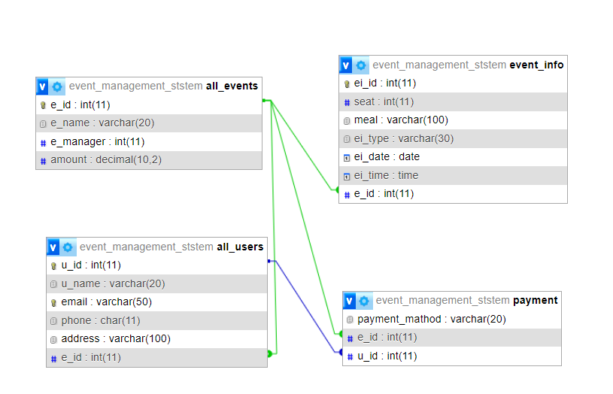

**Chapter 3 | IMPLEMENTATION**

In this chapter, we will discuss the implementation details of the Event Management System. This includes the technology and tools used, the creation of database tables, and the data view of the system.

3.1 Technology & Tools:

The implementation of the Event Management System requires selecting appropriate technologies and tools to develop the system. This may include programming languages, frameworks, and database management systems. The choice of technology depends on factors such as scalability, security, ease of development, and compatibility with the system requirements. Technologies used to implement an event management system include the programming language Python, frameworks such as tkinter, and relational database management systems such as MySQL.

3.2 Database Tables:

The implementation involves creating the necessary database tables to store the relevant information for the Event Management System. This includes tables for events, users, event info, payment, and other entities involved in the system. Each table is designed with appropriate columns to capture the required data, such as event name, date, location, attendee details, organizer information, and related attributes. Primary and foreign key constraints are established to maintain data integrity and enforce relationships between tables.

The design of the database tables considers normalization principles to eliminate data redundancy and ensure efficient storage and retrieval of data. Proper indexing and constraints are applied to optimize query performance and maintain data consistency.

3.3 Data View:

The data view provides an overview of the data stored in the database tables and how it is organized. It includes sample data entries representing events, attendees, organizers, and other relevant entities. The data view showcases the structure and relationships between different tables, demonstrating how the information is stored and interconnected.

In the implementation phase, the technology and tools are leveraged to create the database schema and populate the tables with data. The database is configured, and appropriate security measures are implemented to protect the data and ensure authorized access.

The implementation of the Event Management System involves translating the design into a functional system, where users can interact with the database and perform various operations related to event management. The implemented system provides the necessary functionalities, such as event registration, attendee management, venue booking, scheduling, and communication, to facilitate efficient event management processes.

**Chapter 4 | QUERY RESULTS**

In this chapter, we will explore various queries that can be performed on the Event Management System database. Queries allow us to extract specific information from the database and provide valuable insights into event data, attendee details, and other aspects of the system.

4.1.1 Simple Queries:

Simple queries involve retrieving data from a single table in the database. These queries can provide information such as the list of upcoming events, the details of a specific attendee, or the available venues for a particular date. Simple queries can be executed using SELECT statements with appropriate filtering conditions and projections.

Examples of simple queries include:

- SELECT * FROM event_info WHERE ei_date = "2023-08-04";

- SELECT * FROM all_users WHERE u_name = "James Brown";

- SELECT * FROM event_info WHERE ei_id = 1004;

4.1.2 Joining Queries:

Joining queries involves combining data from multiple tables to retrieve meaningful information. These queries enable us to gather data that requires information from related tables. Join operations, such as INNER JOIN or LEFT JOIN, are used to establish relationships between tables based on common keys.

Examples of joining queries include:

- SELECT e_name, amount, seat, meal, ei_date as date, ei_time as time

FROM all_events ae JOIN event_info ei ON ae.e_id = ei.e_id;

4.1.3 Aggregation:

Aggregation queries involve performing calculations or summarizing data from multiple records. These queries provide useful insights, such as the total number of attendees for an event, the average registration fee, or the maximum capacity of a venue. Aggregation functions like COUNT, SUM, AVG, MAX, and MIN are commonly used in these queries.

Examples of aggregation queries include:

- SELECT count(*) FROM all_users;

- SELECT sum(amount) From all_events;

By executing these queries, valuable information can be extracted from the Event Management System database. The results of these queries provide insights into event data, attendee details, and overall system performance. Query results can be used for reporting, decision-making, and evaluating the success of events.

**Chapter 5 | CONCLUSION**

In this final chapter, we summarize the key findings and outcomes of the Event Management System project. We reflect on the objectives, design, implementation, and query results of the system and draw conclusions regarding its effectiveness and potential impact on event management processes.

The Event Management System was developed with the aim of providing a comprehensive solution for event planning, coordination, and management. Through the implementation of the system, we have achieved the following:

1. Streamlined Event Management:

The system offers a user-friendly interface for event organizers to manage all aspects of event planning and execution. It automates various tasks, including event registration, attendee management, venue booking, scheduling, budgeting, and communication. The centralized platform enhances collaboration and coordination among event organizers, improving overall efficiency and effectiveness.

2. Improved Attendee Experience:

Attendees benefit from a seamless event registration process that includes online registration and payment options. The system facilitates efficient management of attendee details, ensuring a smooth experience for participants. Communication features enable timely updates and notifications, enhancing attendee engagement and satisfaction.

3. Enhanced Data Management:

The system employs a well-designed database schema that supports the storage and retrieval of event-related data. The implementation of appropriate indexing, constraints, and normalization principles ensures efficient data management and maintains data integrity. The data view provides a clear understanding of the structure and relationships within the database.

4. Valuable Insights through Query Results:

The system allows for the execution of various queries, including simple queries, joining queries, and aggregation queries. These queries enable users to extract specific information, generate reports, and gain insights into event data, attendee details, and overall system performance. The query results offer valuable information for reporting, decision-making, and evaluating the success of events.

In conclusion, the Event Management System offers significant advantages in terms of streamlining event management processes, improving attendee experiences, and providing valuable insights through query results. By leveraging appropriate technologies, designing an effective database schema, and implementing robust functionalities, the system has the potential to revolutionize the event management industry.